EXPERIMENT-12
12. A bank wants to approve or reject loan applications based on customer information. Build a Decision Tree Classifier. Classify data using decision tree learning.

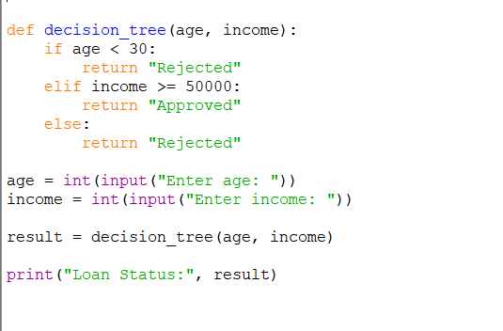
PROGRAM:

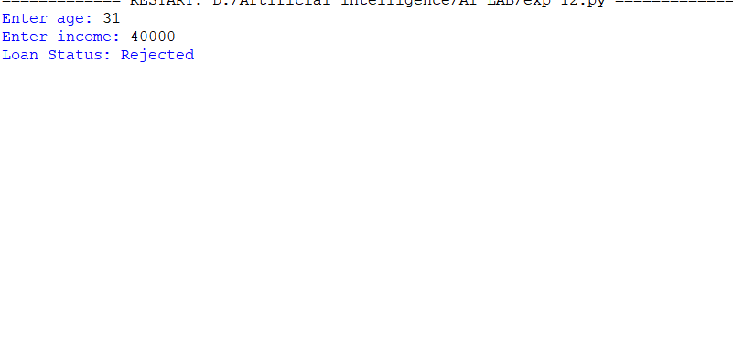
OUTPUT:

